**Steps to Install the GUI for Strain Measurement**

Step1- Double Click on the **MyAppInstaller_web** application.

Step2- Click on **Yes** option in the permission dialog box

Step 3- The following windows opens

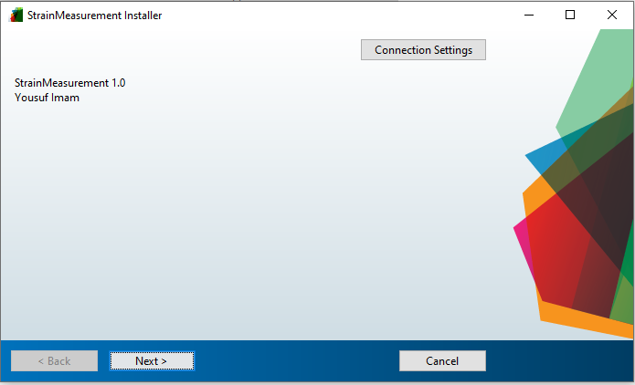

Step 4- Click on Next button

Step 5- Select the folder using **Browse** option where you want to install the GUI. Click on the checkbox of adding shortcut to Desktop. After selecting the folder click on Next button at the bottom of the window.

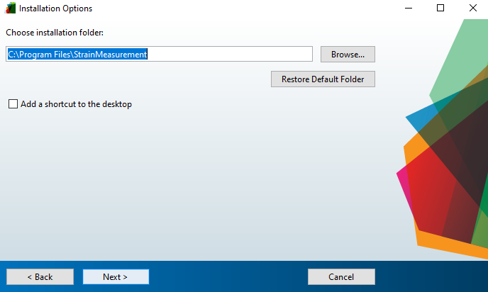

3

2

1

Step 6- In the next window it will ask for Matlab run time installation. Give permission it start downloading the Matlab Runtime environment and then follow the steps as required.

Step 7- Once the Matlab Runtime environment is installed. The Strain measurement GUI will be installed.

Step 8- Double click on the Strain Measurement shortcut on the Desktop. The following window appears

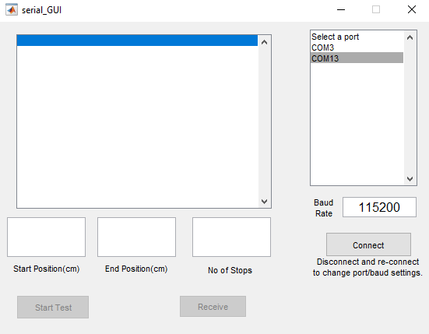

Step 9- Select the appropriate COM port and click on Connect button. The baud rate is set to 115200 (Default) in this case.

Note – Wait for the auto calibration to complete. Ie After you click connect button the setup starts the calibration process and it goes to bottom and clicks the bottom limit switch and then it comes back to the middle position.

Step 10- Enter the start position (In cm), End position (In cm) and number of stops in the following text as shown in the figure below.

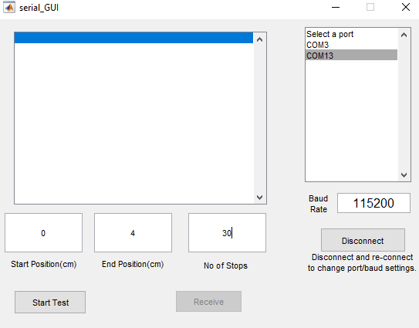

2

1

Step 11- Click on Start Test button.

Step 12- After 2 sec the Receive button gets enabled. Click on receive button.

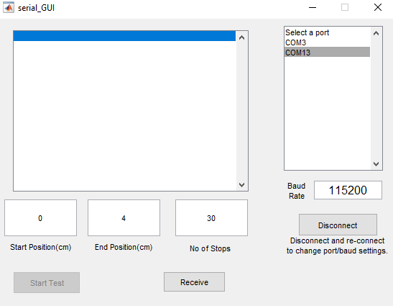

Step 13 – The readings will start to appear on the console of the application. Once the reading is complete “**Readings Completed**” will appear on the console application. And the Start Test and Receive button gets enabled. **Note-** If the Receive button gets enables and you do not see the “**Readings Completed**” on the console then click on Receive button once to get the remaining data.

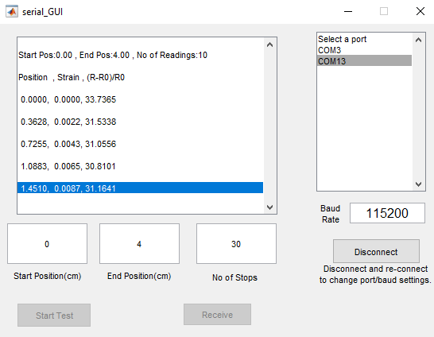

Note - To close the GUI click on the **X** on the top right corner.

Step 14- The data.csv / data.txt will be created on the desktop.

Step 15- Double click on the created data.csv file to open it, the following windows opens

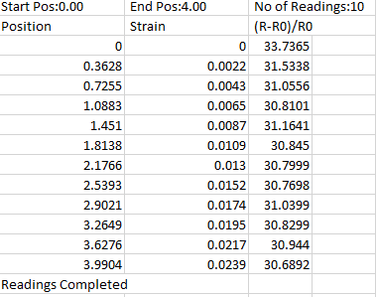

Step 16 – Select the Strain and (R-R0)/R0 column as shown below

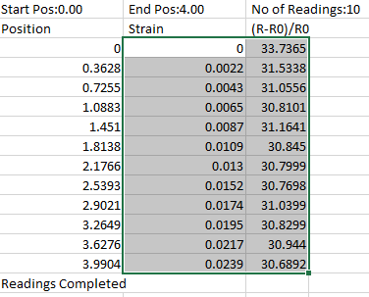

Step 17- Click on the chart option from the insert tab at the top of the excel as shown below

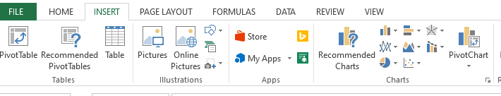

Step 18- Click on scatter xy with smooth lines and markers to get the graph. The x-axis represents the strain % and y-axis represents the (R-R0)/R0 %

